Saipreetha Ramanathan

May,20th,2024

THe Impact of Clmate Change on Global Economies

Contents

Effects of Climate change 1

Causes of Global warming and other health effects 1

Destruction of natural resources of other parts of the world 1

References .3

List of figures

Figure 1 Reconstruction and prediction of atmospheric Co2 contents based on fuel consumption data 2

Figure 2 Global net anthropogenic emissions have continued to rise across all major groups of greenhouse gases 2

# **Effects of Climate change**

Which means crops hit by worsening drought, growing faster because of carbon dioxide fertilization, heat stress increasing, cold stress decreasing, sea levels rising, increasing energy demand for cooling, decreasing energy demand for heating infectious disease spreading, species going extinct. (S.J., 2018)

# **Causes of Global warming and other health effects**

Therefore, these negative impact on climate change has a deterioration rate across the world and to prevent climate change from happening we as a community have to try to change the environment that causes heat warning and eruptions. Climate change has a huge impact on people lives where rising of temperatures causes large amounts of CO2 to be released in the atmosphere which leads to several health illness such as harmful gases in the atmosphere which leads to biohazard air borne disease, the spreading of particles foodborne. Between 2030 and 2050, climate change is expected to cause approximately 250000 additional deaths per year, from undernutrition, malaria, diarrhea and heat stress alone. (World Health Organization, 2023)

# **Destruction of natural resources of other parts of the world**

The way climate change has effects on GDP which creates massive disruptions that leaves an impact on the ozone layer and the atmosphere causing it to lead to floods and emission of gases, deforestation increases the losses natural resources from tree like oxygen water shortages for agriculture that leads to rotting of crops by the increases and decreases of temperature. Climate change could see 4% of global annual economic output lost by 2050 and hit many poorer parts of the world disproportionately hard, a new study of 135 countries has estimated. (Jones, 2022) Bangladesh, India, Pakistan and Sri Lanka’s exposure to wildfires, floods, major storms and also water shortages mean South Asia has 10%-18% of GDP at risk, roughly treble that of North America and 10 times more than the least-affected region, Europe. (Jones, 2022)

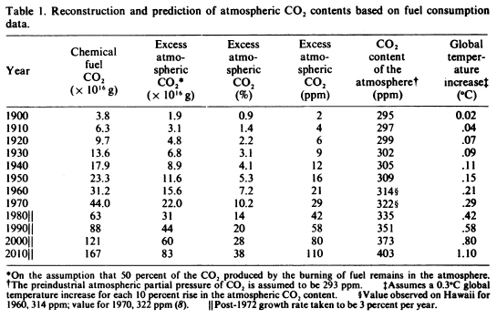

Figure 1 Reconstruction and prediction of atmospheric Co2 contents based on fuel consumption data

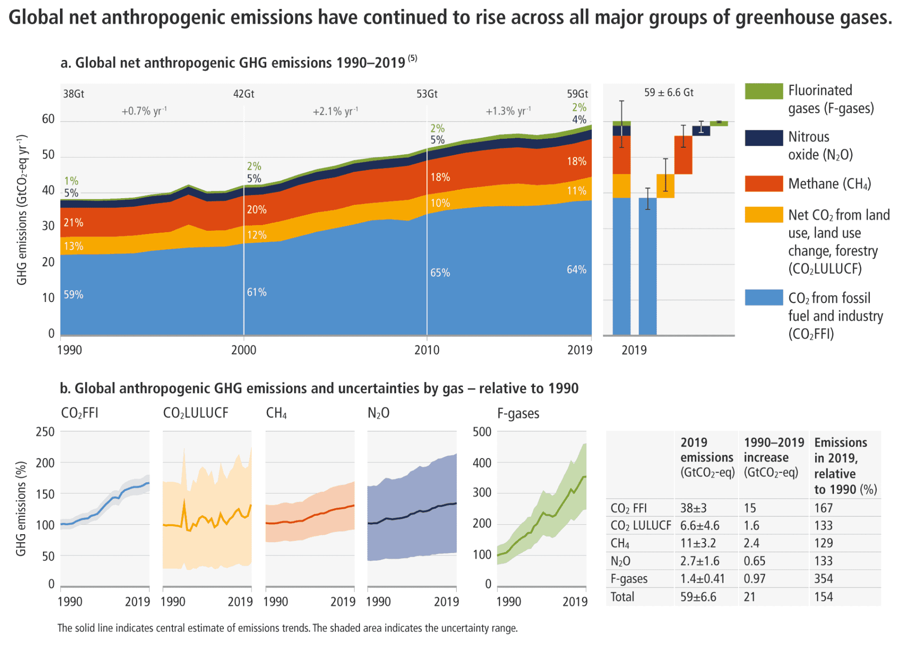

Figure 2 Global net anthropogenic emissions have continued to rise across all major groups of greenhouse gases

# References

Jones, M. (2022, April 28). *REUTERS*. Retrieved from Climate change putting 4% of global GDP at risk, new study estimates: https://www.reuters.com/world/climate-change-putting-4-global-gdp-risk-new-study-estimates-2022-04-27/

S.J., R. (2018). The Ecomomic Impacts of Climate Change. *VRIJE UNIVERSITEIT AMSTRDAM*, 23.

World Health Organization. (2023, October 12). *World Health Organization*. Retrieved from Climate Change: https://www.who.int/news-room/fact-sheets/detail/climate-change-and-health